**Meeting Minutes**

**Date:** 11/10/2023 **Time:** 1:30 pm to 1:50 pm

**Project Title: Service Management system**

**Members:**

|  |  |  |
| --- | --- | --- |
| **Registration No** | **Name** | **Attendance/ Remark** |
| **2021-CS-32** | **Saleem Malik** | **Present** |
| **2021-CS-43** | **Mahnoor Ejaz** | **Present** |

**Type of Meeting:** Physical

**Location: N 8 New Lecture Theatre UET Lahore**

**Agenda: Review and discuss wireframes for the project Meeting**

**Summary:**

The meeting commenced with a warm welcome, and Saleem Malik presented the wireframes for the project, providing a detailed walkthrough of each screen and functionality. The wireframes covered key aspects such as user interface design, navigation flow, and feature placements.

**1.Design Elements:**

The project owner provided feedback on the design elements, emphasizing the need for a cohesive and visually appealing interface. Specific attention was given to color schemes, font choices, and overall aesthetics.

**2. Functionality:**

Both of us engaged in a thorough discussion about the functionality represented in the wireframes. The project owner clarified certain features and suggested potential enhancements to improve user experience.

**3. Navigation Flow:**

The flow of navigation was critically evaluated, ensuring a logical sequence of actions for the end user. Adjustments were discussed to streamline the user journey and make it more intuitive.

**4. Feedback:** Open dialogue was encouraged, and both of us freely shared our thoughts on various aspects of the wireframes. Constructive feedback was noted, and collaborative solutions were explored to address any concerns raised.

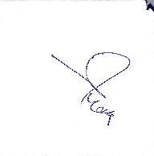**Signature:**

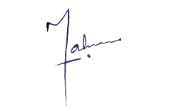

**Owner (Mahnoor Ejaz)**

**Developer (Saleem Malik)**